

FALL SEMESTER 2020-21

MAT3004

APPLIED LINEAR ALGEBRA

**DIGITAL ASSIGNMENT-1**

NAME: VIBHU KUMAR SINGH

REG NO: 19BCE0215

TEACHER: PADMA R.

Instructions: Write in neat hand writing both the questions with your name and registration number written in each sheet. The total number of pages should not exceed 6 pages. Only pdf files should be uploaded in vtop. No word document. First question is compulsory for all.

1. 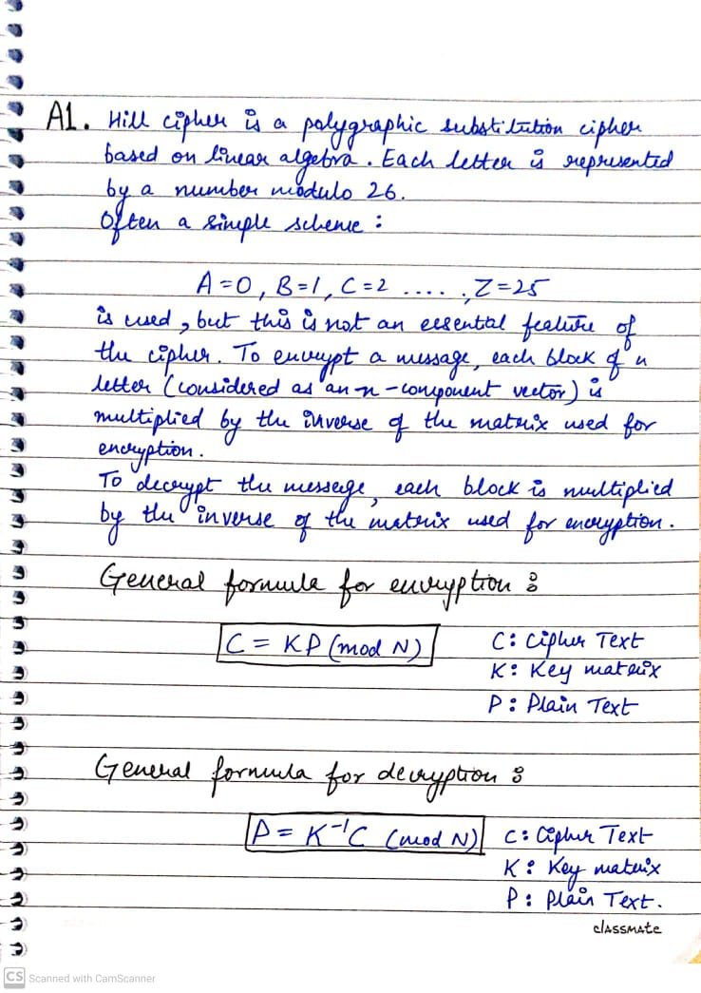Explain the Hill cipher.
2. The six sets of questions are meant for the six groups of students mentioned below the problem. You can consult among your group and do.

We denote the number of symbols by N and the matrix by A and given below the cipher text that has been encrypted with the matrix A mod N. Find the plain text.

1. N=37, A = ^7 3]Encoding : 0 ^ 0, .,9 ^ 9,A ^ 10,...Z ^ 35, blank ^ 36

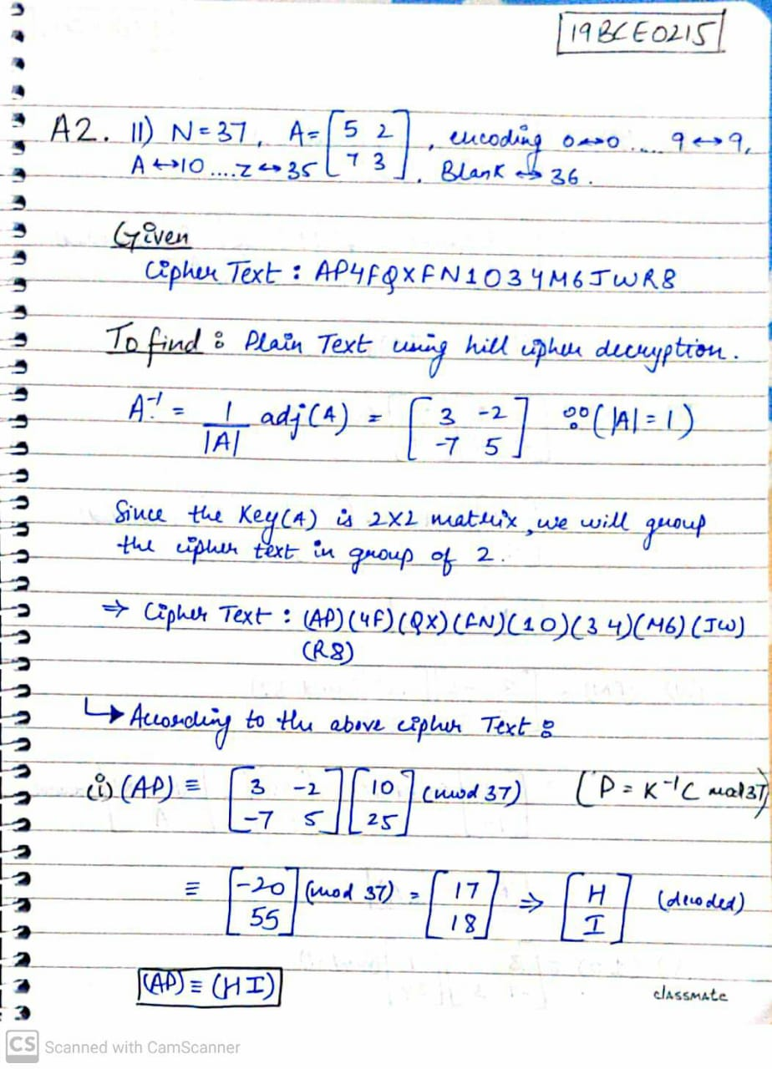Cipher text: AP4FQXFN1O34M6JWR8

